

BRACT’s Vishwakarma Institute of Information Technology

**Context - Aware Personalized AI Debater**

DEPARTMENT OF COMPUTER SCIENCE AND ENGINEERING

(ARTIFICIAL INTELLIGENCE)

|  |  |  |
| --- | --- | --- |
| **Sr No.** | **Name** | **Email Id** |
| 1 | Mrinmayee Deshpande | [mrinmayee.22210087@viit.ac.in](mailto:mrinmayee.22210087@viit.ac.in) |
| 2 | Dipali Gangarde | [dipali.22210638@viit.ac.in](mailto:dipali.22210638@viit.ac.in) |
| 3 | Aniket Dhage | [aniket.22210283@viit.ac.in](mailto:aniket.22210283@viit.ac.in) |

Under Guidance of

Dr. Anuradha Yenkikar, Prof. Pranjal Pandit

**Problem Statement –**

Competitive exam aspirants and job seekers need structured debates to improve reasoning and articulation. However, existing AI debate systems **lack personalization, contextual awareness, and real-time relevance**, making them ineffective for adaptive learning. Their **generic and rigid arguments** fail to align with users’ knowledge, past debates, and industry needs, limiting deep analysis and logical rebuttals. A context-aware personalized AI debater can adapt to users' debate styles, offer real-time insights, and provide interactive feedback. By using AI-driven learning, dynamic content updates, and tailored argumentation, it can boost engagement, enhance analytical thinking, and improve exam and interview preparation.

**Introduction -**

Artificial Intelligence (AI) is revolutionizing education, professional training, and competitive preparation by enhancing learning experiences and automating assessments. However, existing AI debate systems lack adaptability, often providing rigid and generic arguments that do not cater to individual users’ debate styles, prior knowledge, or evolving preferences. This limitation hinders the development of critical thinking and reasoning skills, making it difficult for learners to engage in meaningful, interactive debates.

This project proposes a **Context-Aware Personalized AI Debater** that leverages **Natural Language Processing (NLP) and Generative AI (GenAI)** to generate adaptive, real-time arguments. Unlike traditional AI debate systems, this model will analyze users' past interactions, debate preferences, and knowledge levels to provide relevant and structured responses. It will also incorporate real-time knowledge retrieval, ensuring factually accurate and dynamic debate interactions. The system will support both **text and voice-based discussions**, making it suitable for academic training, professional development, and policy discussions.

By integrating **context awareness, real-time adaptability, and multi-perspective analysis**, this AI debater aims to enhance users' logical reasoning and articulation skills. The system’s continuous learning mechanism will refine responses based on user engagement, making debates progressively more relevant and challenging. With applications in **education, corporate training, and legal discussions**, this AI-driven solution has the potential to transform structured argumentation and decision-making across various sectors.

**Objectives –**

1. **Enhance Reasoning & Articulation** - Improve logical reasoning and communication skills through structured debates.
2. **Adaptability** – Support various debate formats (academic, professional, and casual).
3. **Multi-Modal Support** – Enable both text-based and voice-based debate interactions.
4. **Personalized Debates** – Utilize NLP and GenAI to tailor debate topics, complexity, and argumentation style based on user preferences.

**Literature Survey –**

A study on **DEBO**, an AI-powered debate education tool using **ChatGPT**, found that it enhances **divergent thinking** and provides **detailed performance analytics**. However, limitations such as **occasional inaccuracies, debate quality issues, and response speed** were noted. The study highlights the **potential of generative AI in debate training** while identifying areas for improvement. [1]

DebateBrawl, an **AI-driven debate system** integrated **LLMs, Genetic Algorithms, and Adversarial Search** to enhance strategic argumentation. It achieved **high factual accuracy (92%)** and adapted in real-time, with **85% of users reporting improved debating skills**. Experimental results showed **balanced AI-human debate outcomes**, making it an effective **educational tool** for AI-assisted discourse while addressing ethical concerns through **fact-checking and transparency measures**.[2]

A study proposed a **multi-modal persuasive dialogue system** to address limitations in task-oriented conversational agents when users face **goal unavailability**. The system incorporated a **goal controller** to identify conflicts and a **goal persuader** to steer users toward similar, achievable goals using **personalized strategies**. A new evaluation metric, **Persuasiveness Measurement Rate (PMeR)**, was introduced to assess the system’s effectiveness. Results showed **quantitative and qualitative improvements**, demonstrating its superiority over traditional task-oriented agents.[3]

Computational Argumentation evolved to enhance AI-driven debates, with **IBM’s Project Debater (2019)** being a key milestone. The study addressed challenges like **argument retrieval, stance classification, and rebuttal generation**. It also provided insights into debating system workflows and available research tools. [4]

**System Architecture –**

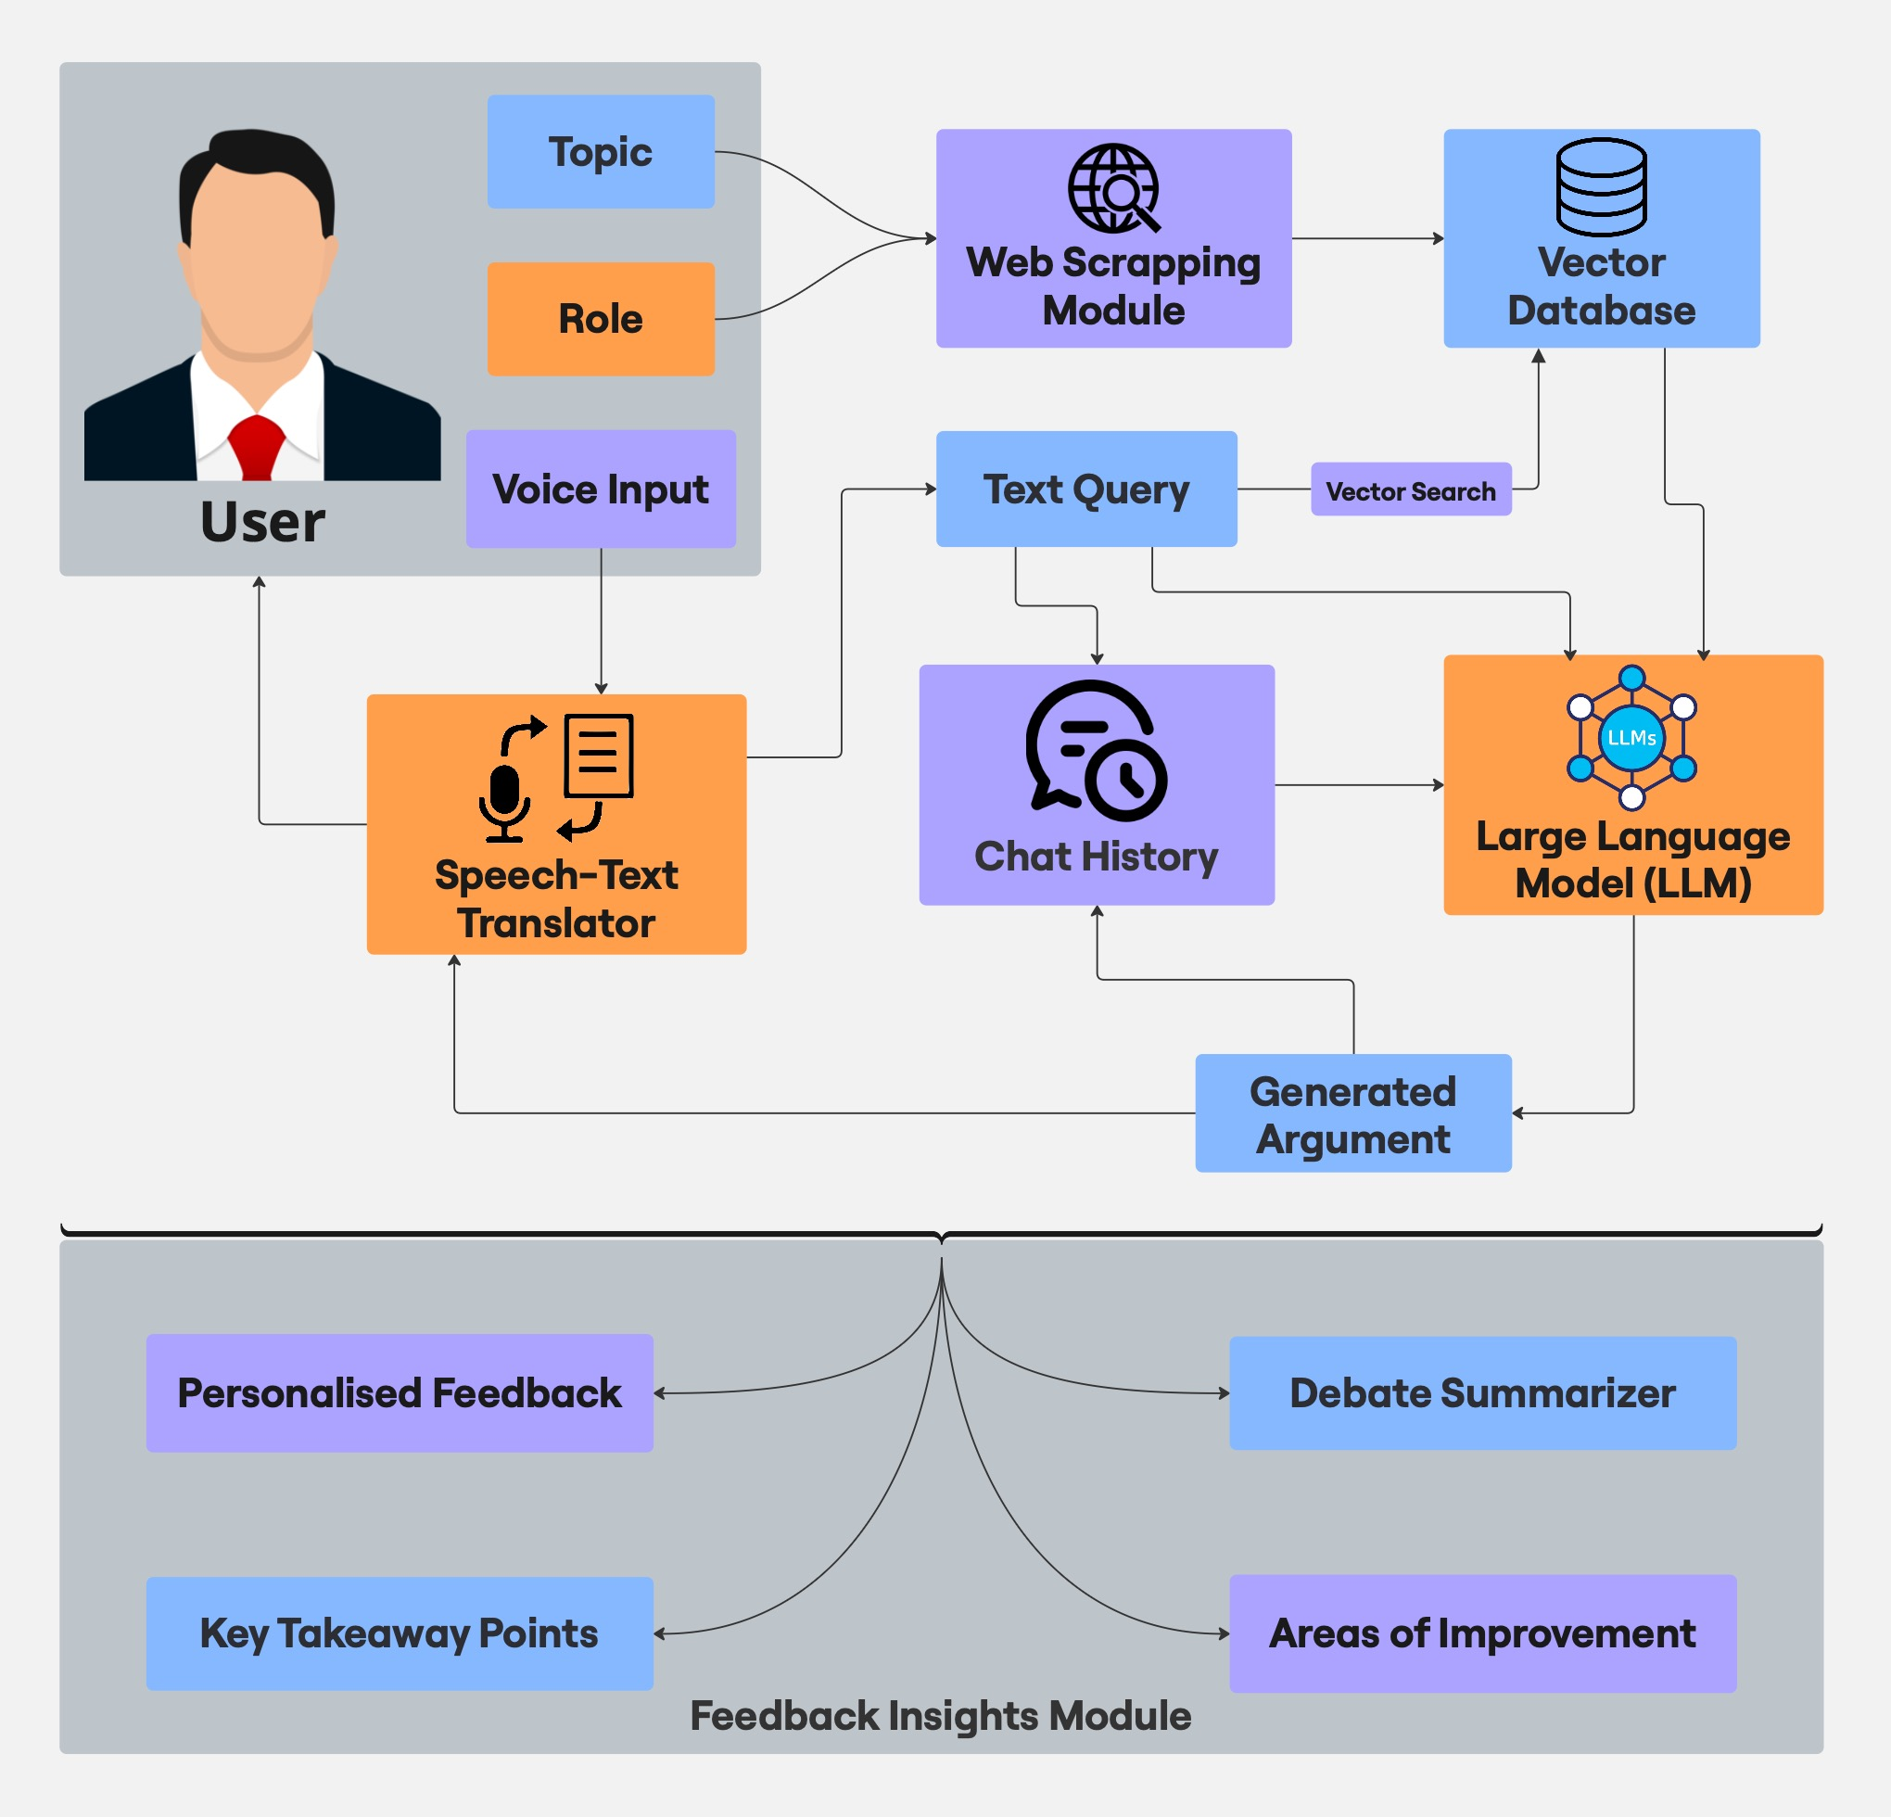

**Fig 1. System Architecture of the proposed system**

**Methodology –**

The system is designed to enhance debate preparation by leveraging **React for the frontend**, **Gemini model for backend processing**, and **FastAPI** for communication. It integrates **web scraping, vector-based retrieval, and Retrieval-Augmented Generation (RAG)** to generate contextually relevant arguments.

#### ****Process Flow****

The system follows a structured flow to generate and refine debate arguments dynamically:

1. **User Input & Topic Selection**
   * The user provides a **topic** (e.g., Authenticity of Uniform Civil Code) and a **role** (e.g., Opposition).
   * The system checks if relevant knowledge is available in the **vector database**.
2. **Web Scraping & Knowledge Retrieval**
   * If knowledge is unavailable, the **web scraping module** (using **Beautiful Soup**) extracts relevant information from online sources.
   * The retrieved data is stored as vector embeddings in the **vector database** for efficient retrieval.
3. **Argument Generation Using LLM (Gemini Model)**
   * The system uses **RAG** to fetch relevant data from the **vector database** and **chat history**.
   * The **Gemini model** generates a structured argument based on the retrieved context.
4. **Speech & Text Processing**
   * The user’s spoken argument is converted into text using the **Speech-Text Translator**.
   * The LLM-generated argument is converted into **audio** for an interactive debate experience.
5. **User Interaction & Response Handling**
   * The user can provide counterarguments based on the generated response.
   * The system repeats the process until the user chooses to conclude the debate.

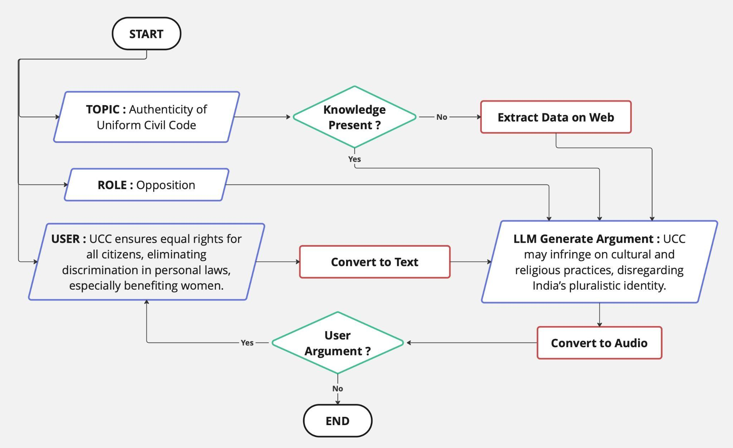

**Fig 2. Flowchart of the system**

**Benefits and Impact –**

1. **Bridges the Gap** – Adapts to users’ debate styles and real-time knowledge needs.
2. **Improves Preparation** – Enhances reasoning, articulation, and rebuttal skills for exams and interviews.
3. **Real-Time Relevance** – Integrates the latest facts, policies, and industry updates.
4. **Dynamic Learning** – Evolves with user interactions, providing personalized feedback.
5. **Multi-Industry Applications** – Expandable to academic, corporate, and legal fields.

**Weekly Execution Plan –**

1. **Week 1 –** Topic finalization
2. **Week 2 –** Literature survey, surveying the existing projects
3. **Week 3 –** Defining the objectives, listing down the benefits and impacts of the project, defining the tech stack and the approach.
4. **Week 4 –** Creating a basic chatbot.
5. **Week 5 –** Integrating voice input and output to the chatbot.
6. **Week 6 -** Creating frontend and linking it with the backend.
7. **Week 7 –** Learning RAG, beautiful soup and other web scraping techniques.
8. **Week 8 –** Actual implementation of RAG into the project.
9. **Week 9 –** Testing the system
10. **Week 10 –** Documentation

**Conclusion –**

The **Context-Aware Personalized AI Debater** enhances structured debates by integrating **real-time data retrieval, personalized learning, and multi-modal interaction**. Unlike traditional AI systems, it dynamically adapts to users’ debate styles, prior knowledge, and evolving preferences using **Natural Language Processing (NLP) and Generative AI (GenAI)**. By retrieving **up-to-date information** through web scraping and vector-based search, it ensures debates remain factually accurate and contextually relevant. With **multi-perspective analysis**, users can explore diverse viewpoints, improving their argumentation and rebuttal skills. Supporting both **text and voice-based interactions**, the system provides an immersive learning experience. Its applications span **education, corporate training, legal argumentation, and policy discussions**, making AI-powered debating more effective and interactive.

**References –**

1. Lee, U., Jeong, Y., Koh, J., Byun, G., Lee, Y., Hwang, Y., Kim, H., & Lim, C. (2024). Can ChatGPT be a debate partner? Developing ChatGPT-based application “DEBO” for debate education, findings and limitations. **Educational Technology & Society, 27**(2), 321-346.
2. **Aryan, P.** (2024). LLMs as debate partners: Utilizing genetic algorithms and adversarial search for adaptive arguments. arXiv. <https://doi.org/10.48550/arXiv.2412.06229>
3. **Tiwari, A., Saha, S., Sengupta, S., Maitra, A., Ramnani, R., & Bhattacharyya, P.** (2022). Persona or context? Towards building context-adaptive personalized persuasive virtual sales assistant. Proceedings of AACL-IJCNLP 2022, 1035–1047. Association for Computational Linguistics.
4. **Bar-Haim, R., Ein-Dor, L., Orbach, M., Venezian, E., & Slonim, N.** (n.d.). Advances in debating technologies: Building AI that can debate humans. IBM Research.